[TITLE PAGE – PLEASE SUBMIT THIS PAGE AS SUPPLEMENTARY FILE]

Title
Title in Portuguese
Title in Spanish

Author 1
Affiliation: [E.g.: Department, Institution, City, Country]
E-mail:
CV Lattes:
ORCID:

Author 2
Affiliation: [E.g.: Department, Institution, City, Country]
E-mail:
CV Lattes:
ORCID:

Corresponding author:
Street address:

Reviewers: [Please suggest the names, and respective e-mails, of at least two potential reviewers for the article].

Title
Title in Portuguese
Title in Spanish

Abstract: insert here the manuscript abstract. In all languages, abstracts should be structured as following: introduction, objectives, methods, results and conclusion. Each abstract should have at least 200 up to 250 words.
Keywords: insert up to 5 keywords using a period mark as delimiter.

Resumo: insert here the manuscript abstract written in Brazilian Portuguese. In all languages, abstracts should be structured as following: introduction, objectives, methods, results and conclusion. Each abstract should have at least 200 up to 250 words.
Palavras-chave: insert up to 5 keywords using a period mark as delimiter.

Resumen: insert here the manuscript abstract written in Spanish. In all languages, abstracts should be structured as following: introduction, objectives, methods, results and conclusion. Each abstract should have at least 200 up to 250 words.
Palabras-clave: insert up to 5 keywords using a period mark as delimiter.

1 Introduction

Type your manuscript using Arial 12pts, line spacing 1.5, without indentation.

Citations with more than three lines should be typed in Arial 10pts, single line spacing, with a 4 cm indentation from the left margin.

Citations should be formatted as following:

Single authors

(Rodrigues 2013)

Two authors

(Mendes, Ometto 2019)

Three or more authors

(Roy, Deschênes, Margni 2012; Mendes, Ometto 2019)

(Azevedo, van Zelm, Hendriks, Bobbink, Huijbregts 2013)

2 Materials and Methods

3 Results and Discussion

Table 1. Example of table title.
Header | Header | Header | Header
Line indicator | data | data | data
Line indicator | data | data | data
Line indicator | data | data | data
Line indicator | data | data | data
Line indicator | data | data | data
Source: (Author1, Author2 AAAA).

Figure 1. Example of figure title.
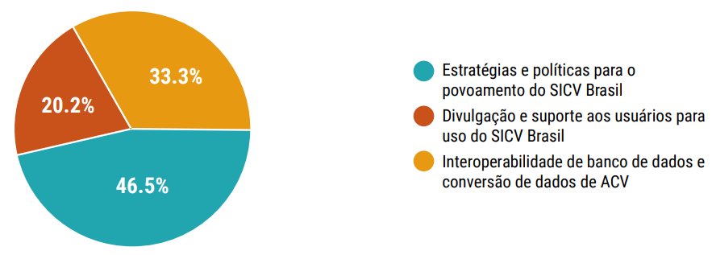
Source: (Relatório... 2016).

Figure 2. Another figure example.

Source: the authors.

4 Conclusion

Acknowledgements

Acknowledgments to people who contributed to the study or manuscript and are not listed as authors.

Funding

Please list here all agencies or grants funding the study. Please use full, not translated, agencies names and, when available, the grant numbers.

References

Please format all references according to ISO 690:2010. Leave a single line space between each reference and make sure all the links are active and pointing to the correct source. Some examples of references formatting according to different types of resources:

Journal article
AZEVEDO, Ligia B., VAN ZELM, Rosalie, HENDRIKS, A. Jan, BOBBINK, Roland and HUIJBREGTS, Mark A.J., 2013.Global assessment of the effects of terrestrial acidification on plant species richness.Environmental Pollution [online]. March 2013. Vol. 174, p. 10–15. [Accessed 5 August 2019].DOI 10.1016/j.envpol.2012.11.001.Availablefrom: https://linkinghub.elsevier.com/retrieve/pii/S0269749112004782
ROY, Pierre-Olivier, DESCHÊNES, Louise and MARGNI, Manuele, 2012. Life cycle impact assessment of terrestrial acidification: modeling spatially explicit soil sensitivity at the global scale. Environmental Science & Technology [online]. 7 August 2012. Vol. 46, no. 15, p. 8270–8278. [Accessed 5 August 2019].DOI 10.1021/es3013563. Availablefrom: http://pubs.acs.org/doi/10.1021/es3013563

Book, monograph part
MENDES, Natalia Crespo and OMETTO, Aldo Roberto, 2019. Acidificação terrestre. In: Rede de Pesquisa de Avaliação do Impacto do Ciclo de Vida: Recomendação de modelos de Avaliação de Impacto do Ciclo de Vida para o contexto brasileiro / RAICV [online]. Brasília, DF: Ibict. p. 165.[Accessed 5 August 2019]. Available from: http://acv.ibict.br/wp-content/uploads/2019/07/Relat%C3%B3rio-de-Recomenda%C3%A7%C3%B5es-de-Modelos-de-Avalia%C3%A7%C3%A3o-de-Impacto-para-o-Contexto-Brasileiro.pdf

Report
Relatório BRACV: Fórum Brasileiro de Avaliação do Ciclo de Vida, 2016. [online]. Brasília, DF: Ibict. [Accessed 5 August 2019]. Available from: http://acv.ibict.br/wp-content/uploads/2019/04/Relatorio-BRACV2017_publicado-2018.pdf

Theses and Dissertations
RODRIGUES, Thiago Oliveira, 2013. Avaliação dos impactos ambientais da produção de bioóleo a partir de serragem no estado do Pará [online]. Tese (Doutorado em Ciências Florestais). Brasília, DF: Universidade de Brasília, Faculdade de Tecnologia. [Accessed 5 August 2019]. Available from: http://repositorio.unb.br/handle/10482/14153

